Course-End Project

Automating Deployment to Azure Web App with Application Containers
Steps to be followed:

- Create Terraform scripts to automate Azure infrastructure automatically
- Configure Azure Web app for Containers with high availability configuration
- Configure Jenkins to automate CI CD workflow

Step 1: Create Terraform scripts to automate Azure infrastructure automatically

  - Open the terminal in the DevOps lab

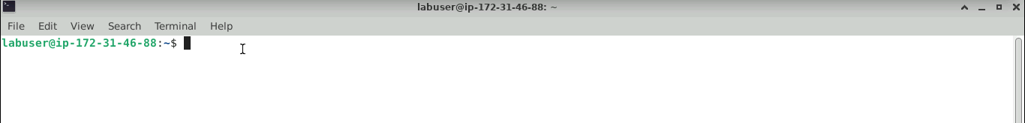

  - Run the below command to make a directory
mkdir azure

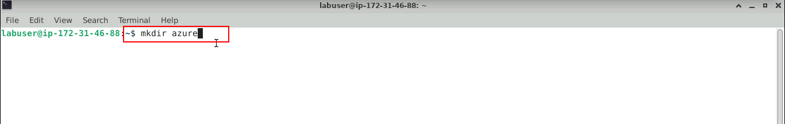

  - Run the below command to enter the created directory
cd azure

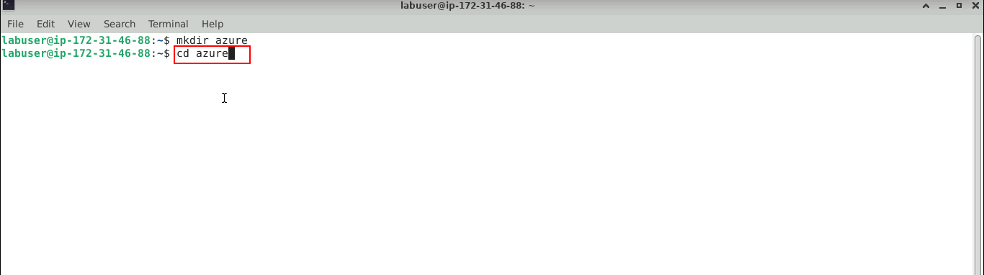
The Azure directory opened successfully.

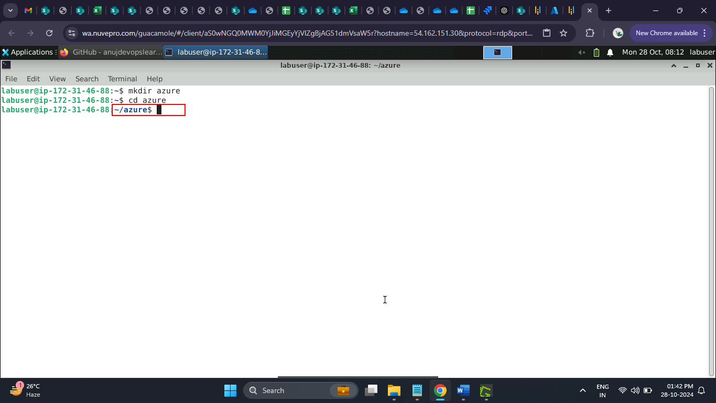

  - Navigate to the Azure portal to copy the resource group name and the subscription id

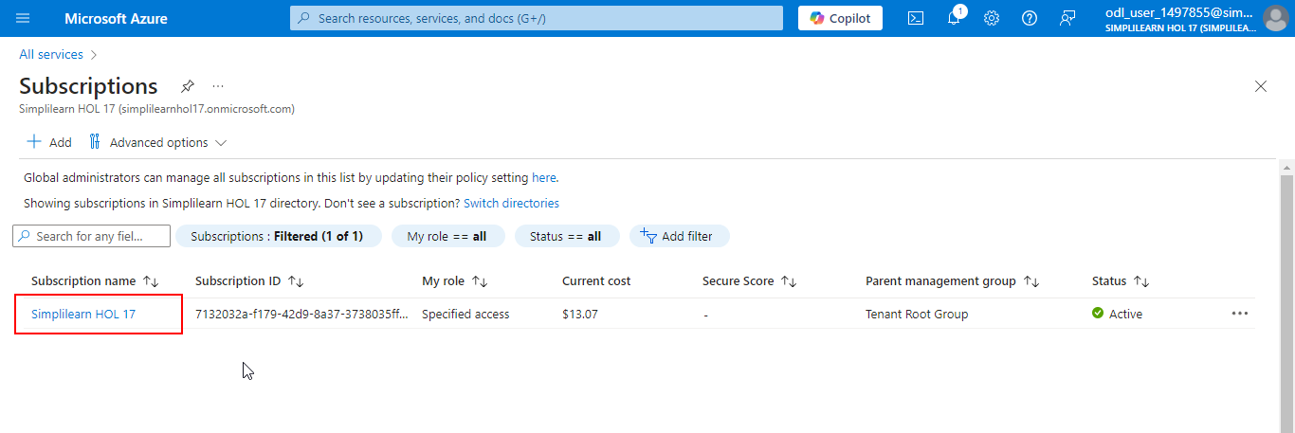

  - Copy the Subscription ID

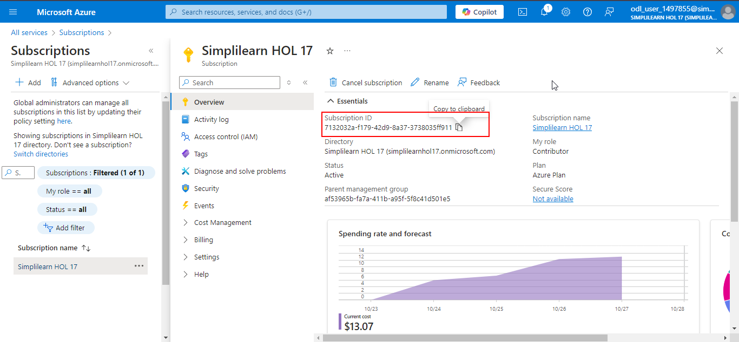

  - Navigate to the Resource groups

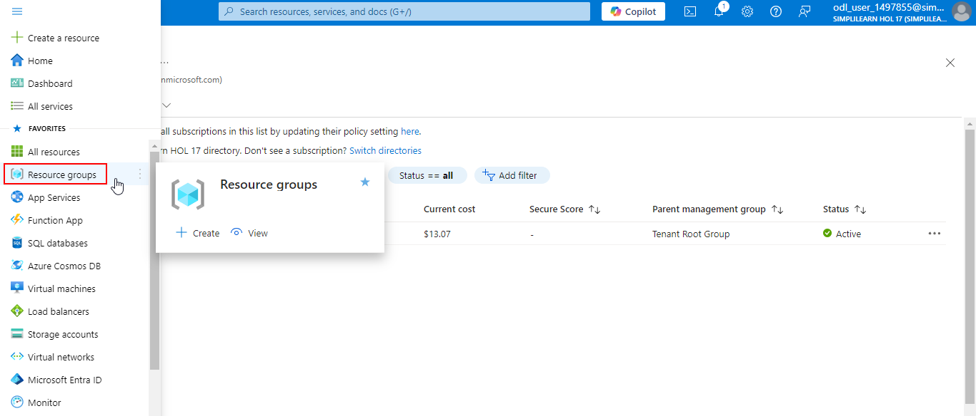

  - Copy the Resource group name

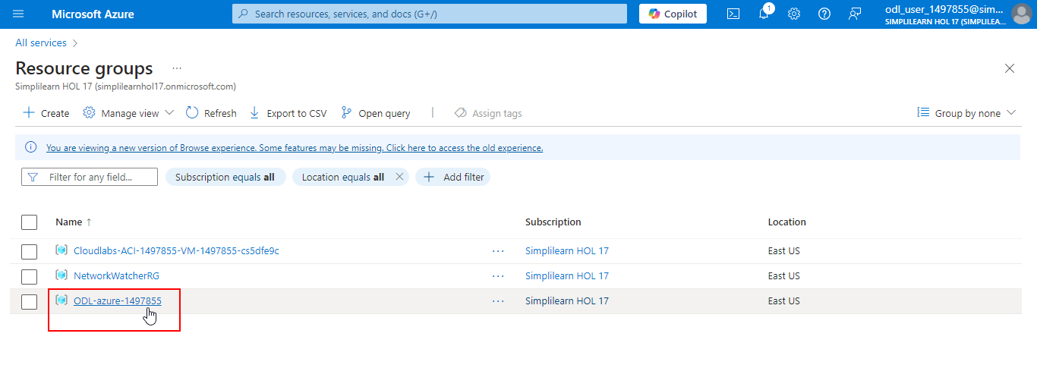

  - Navigate back to the terminal

  - Enter the code below to Create the backend.tf file with the specified content

cat > backend.tf << EOL
terraform {
required_providers {
azurerm = {
source = "hashicorp/azurerm"
version = "4.4.0"
}
}
}

provider "azurerm" {
features {}
resource_provider_registrations = "none"
subscription_id = "7132032a-f179-42d9-8a37-3738035ff911"
}
EOL

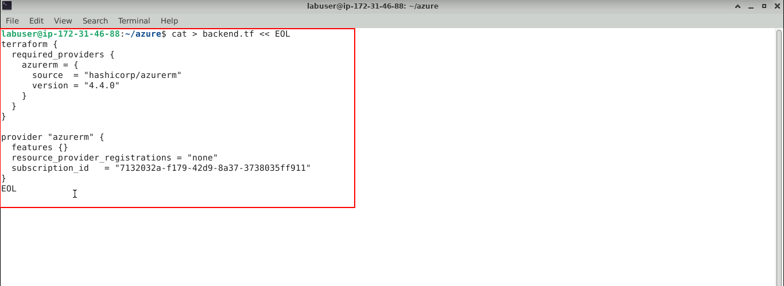

  - Enter the code below to Create the variables.tf file with the specified content

cat > variables.tf << EOL
variable "project_name" {
type = string
description = "Project name"
default = "azurewebapp"

validation {
condition = can(regex("^[a-zA-Z0-9]*\$", var.project_name))
error_message = "The project_name must be alphanumeric."
}
}

variable "image_name" {
type = string
description = "Image name"
default = "backendapp"

validation {
condition = can(regex("^[a-zA-Z0-9]*\$", var.image_name))
error_message = "The image_name must be alphanumeric."
}
}

variable "resource_group_location" {
type = string
description = "Location for all resources."
default = "eastus2"
}

variable "resource_group_name_prefix" {
type = string
description = "Prefix of the resource group name that's combined with a random ID so name is unique in your Azure subscription."
default = "ODL-azure-1497855"
}

variable "subscription_id" {
type = string
description = "Subscription ID for Logged in Azure Account"
default = "7132032a-f179-42d9-8a37-3738035ff911"
}
EOL
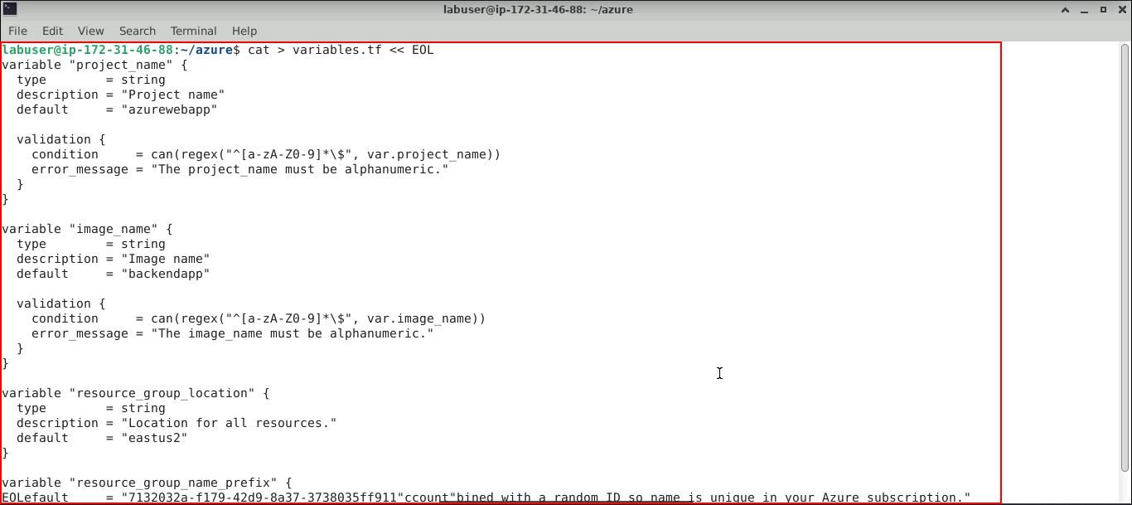

  - Enter the code below to Create the acr.tf file with the specified content

cat > acr.tf << EOL
resource "azurerm_container_registry" "acr" {
name = "\${var.project_name}azurewebappregistry"
resource_group_name = "ODL-azure-1497855"
location = "\${var.resource_group_location}"
sku = "Standard"
admin_enabled = true
}
EOL

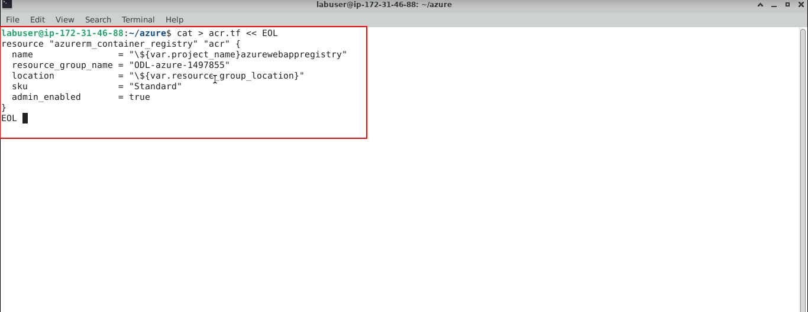

  - Enter the code below to Create the app_service.tf file with the specified content

cat > app_service.tf << EOL
resource "azurerm_service_plan" "backend" {
name = "\${var.project_name}-appserviceplan"
resource_group_name = "ODL-azure-1497855"
location = "\${var.resource_group_location}"
os_type = "Linux"
sku_name = "P1v2"
}

resource "azurerm_linux_web_app" "backend" {
name = "\${var.project_name}-webapplication"
resource_group_name = "ODL-azure-1497855"
location = "\${var.resource_group_location}"
service_plan_id = azurerm_service_plan.backend.id

site_config {
always_on = "true"

application_stack {
docker_image_name = "\${azurerm_container_registry.acr.login_server}/\${var.image_name}:latest"
docker_registry_url = "https://\${azurerm_container_registry.acr.login_server}"
docker_registry_username = azurerm_container_registry.acr.admin_username
docker_registry_password = azurerm_container_registry.acr.admin_password
}
}
}
EOL

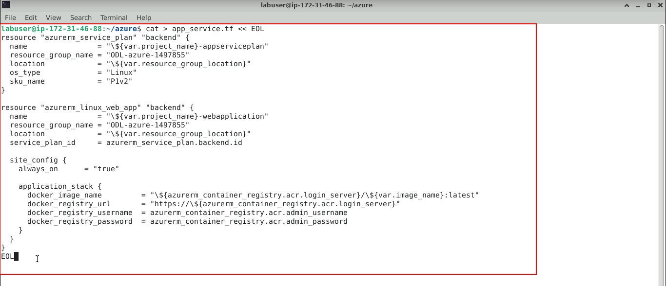

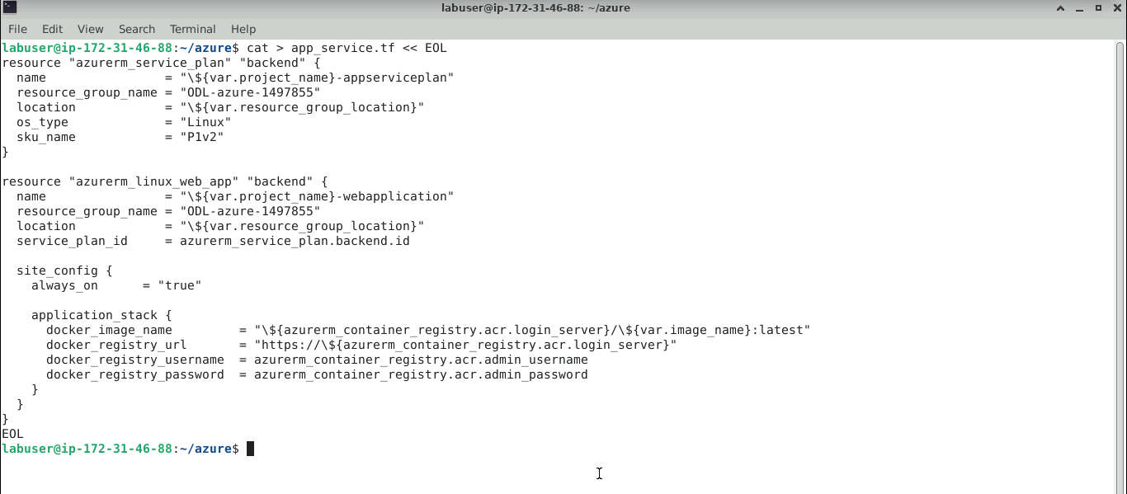

  - Run the command below to configure the Azure CLI to authenticate with your Azure account, allowing Terraform scripts to be applied
curl -sL https://aka.ms/InstallAzureCLIDeb | sudo bash

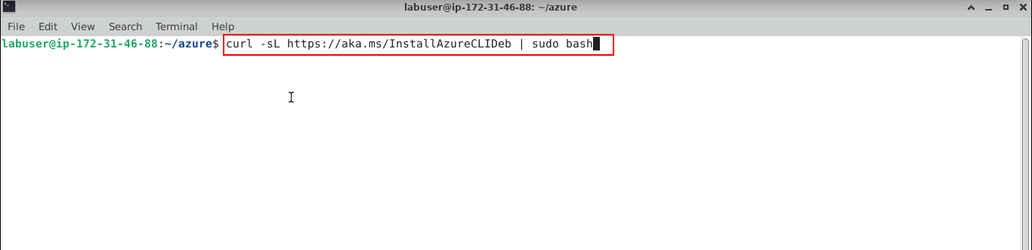

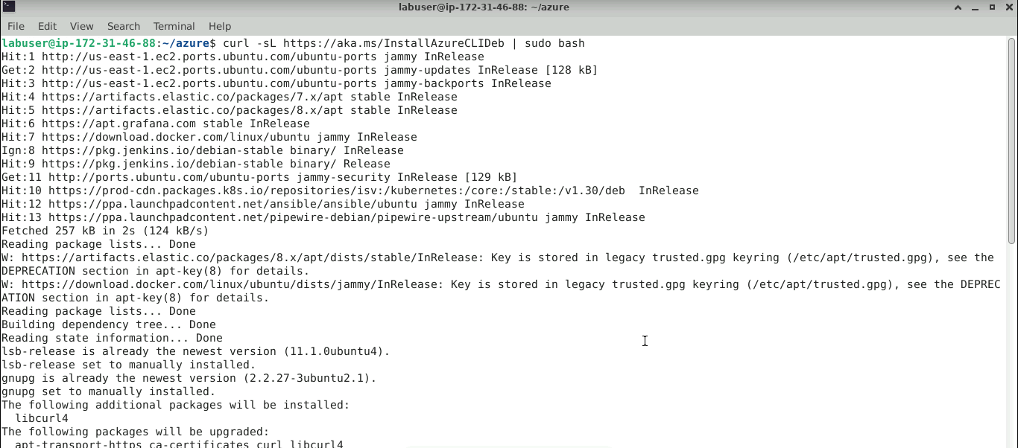

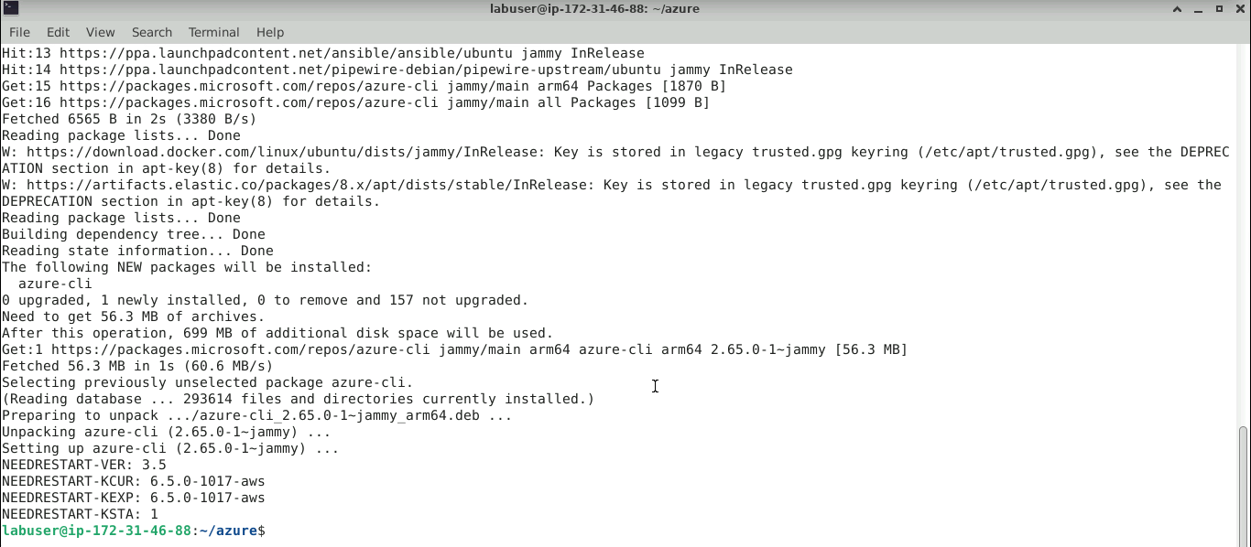

  - Run the command below to proceed with authentication to Azure Cloud
az login

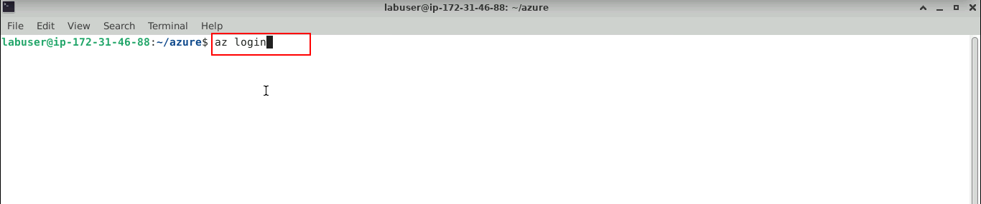

The Azure login page opens in the browser.

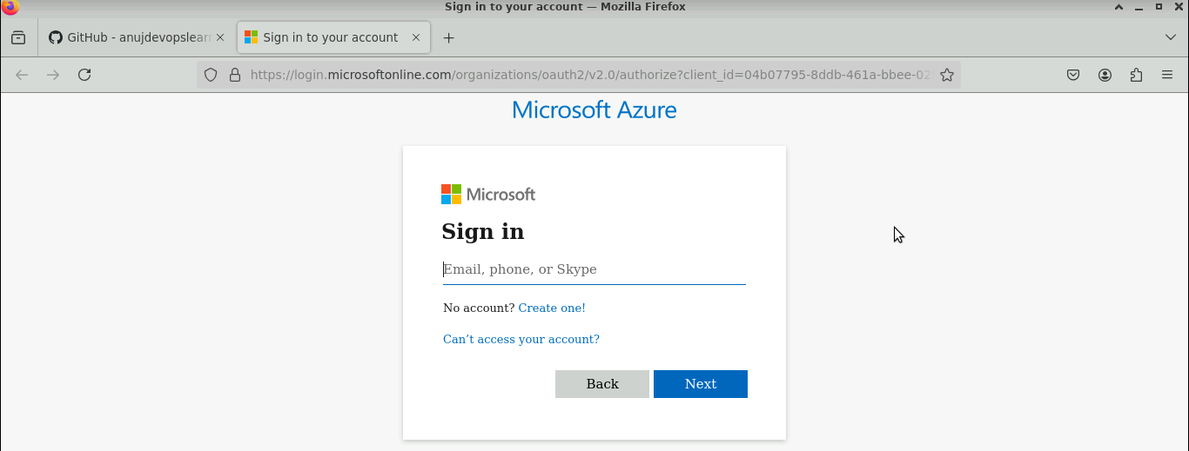

  - Navigate to the Azure lab and copy the login credentials

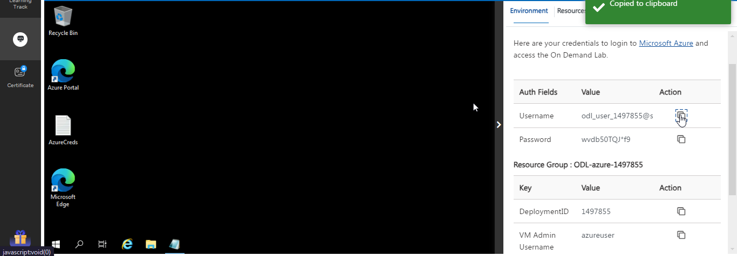

  - Paste the Username in the browser and click on the Next button

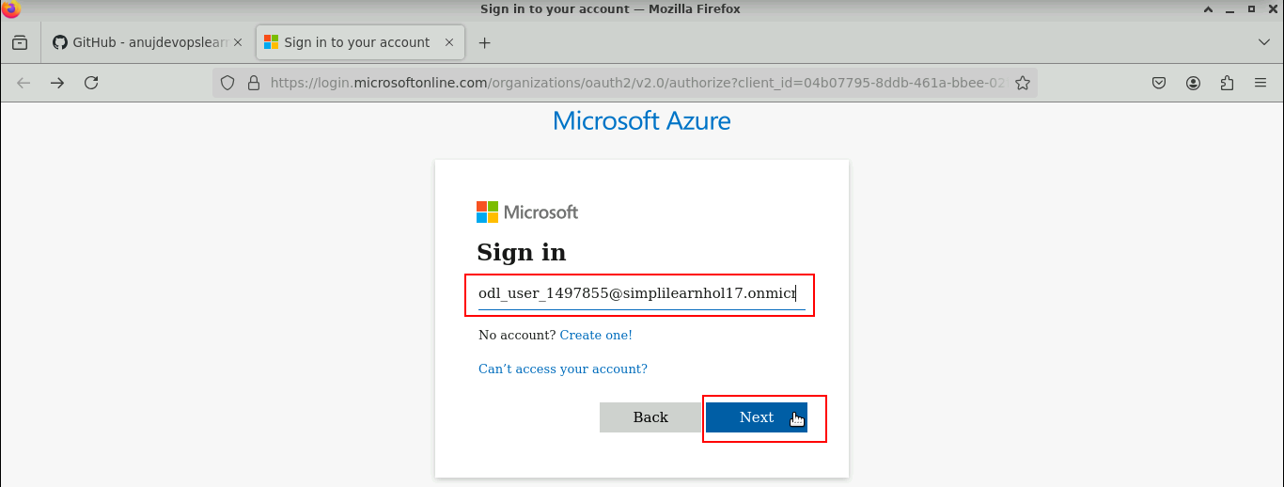

  - Copy the password from the Azure lab

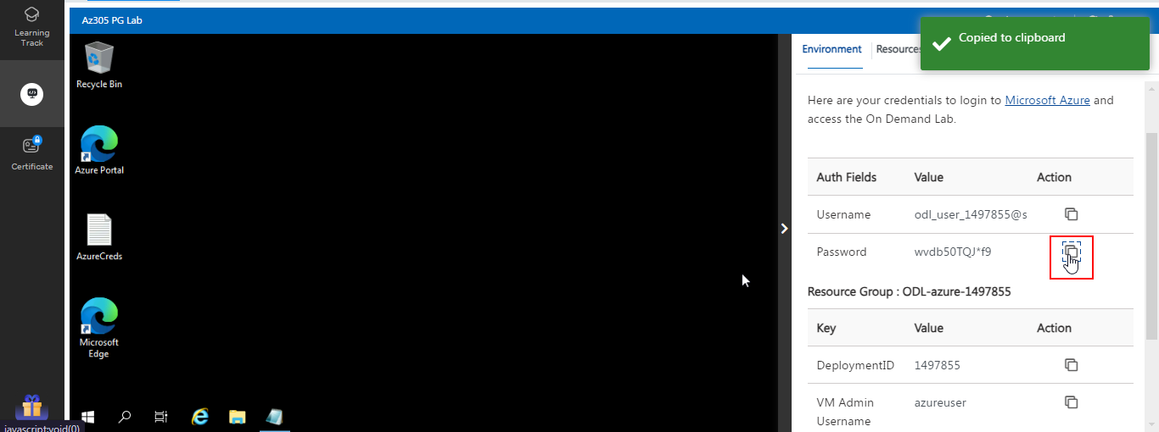

  - Paste the Password in the browser and click on the Sign in button

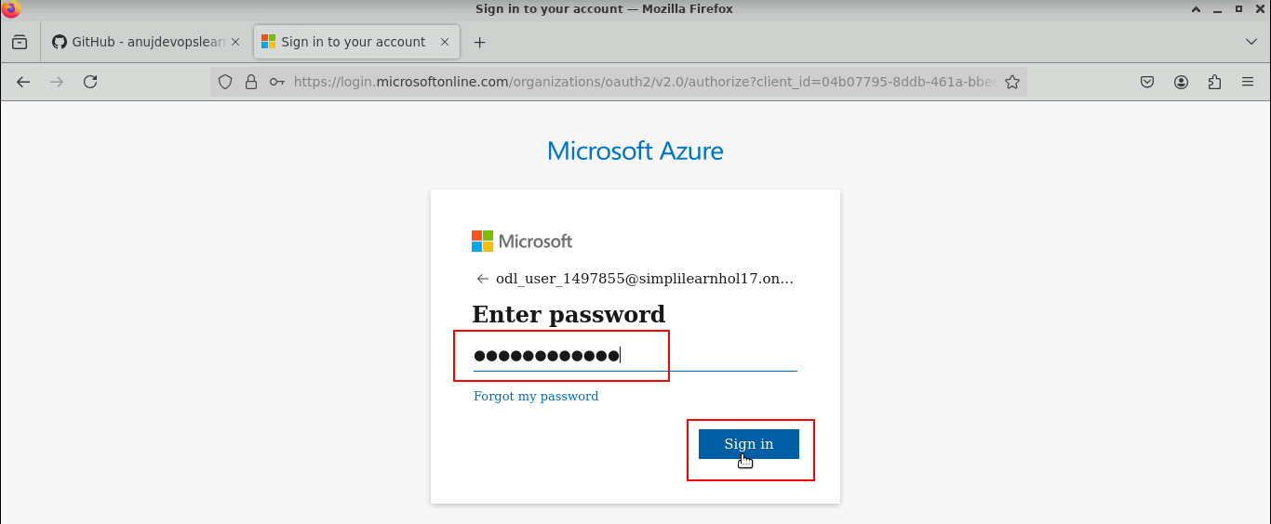

You will be successfully logged into the Azure account.

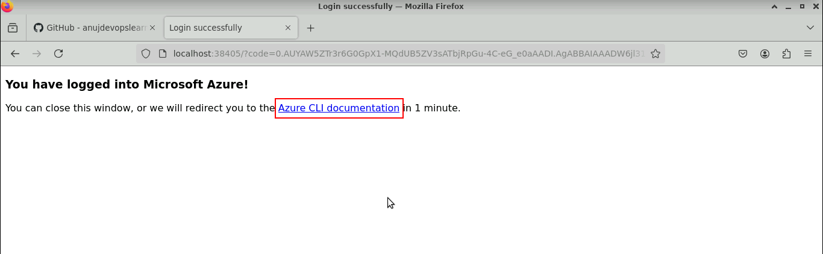

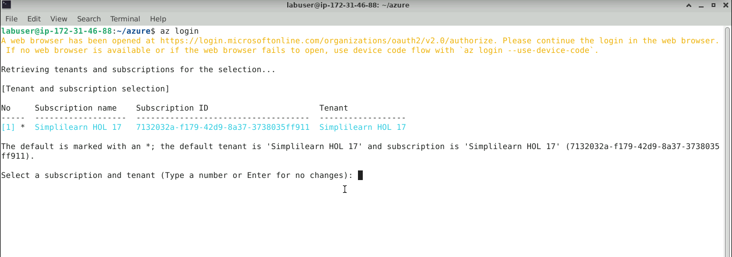

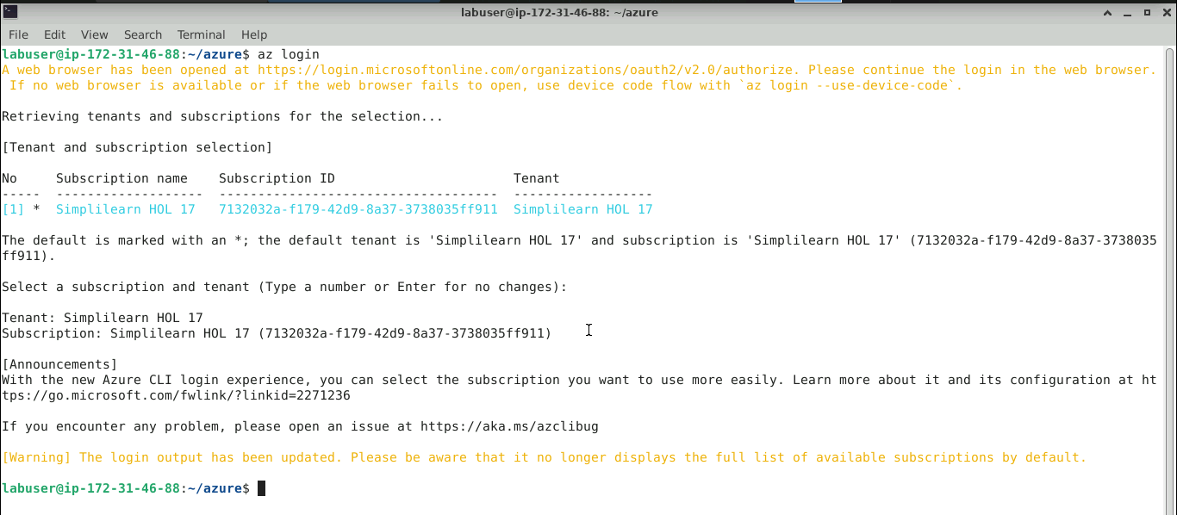

  - Execute the below command to get the Azure account list
az account list

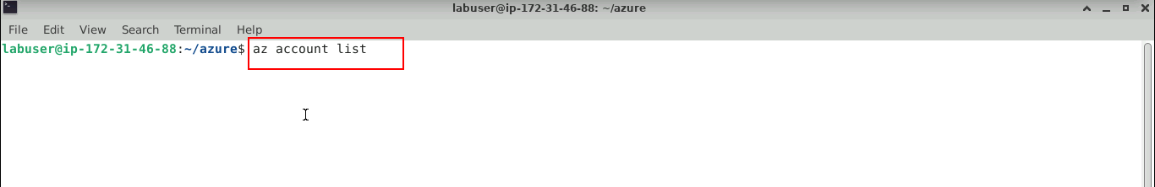

The Azure account list is displayed successfully.

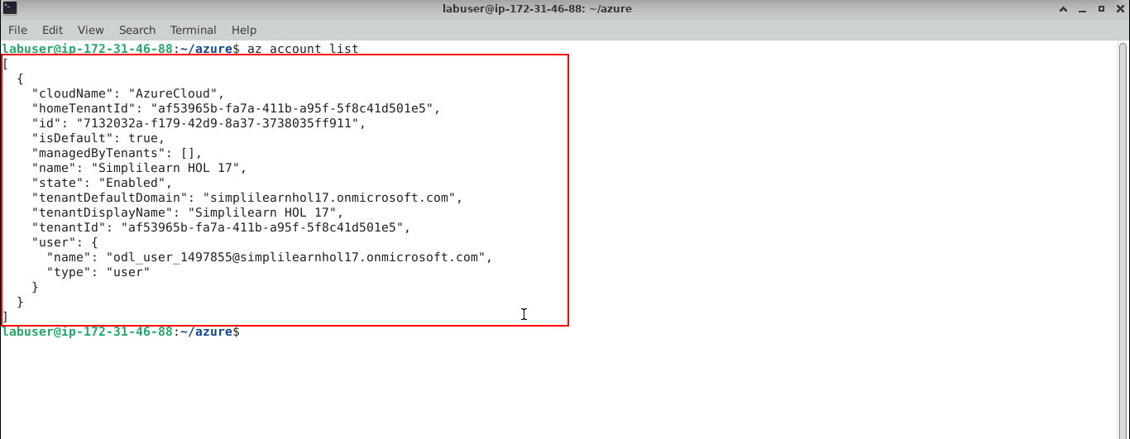

Step 2: Configure Azure Web app for Containers with high availability configuration

  - Navigate back to the terminal and run the command below to initialize Terraform
terraform init

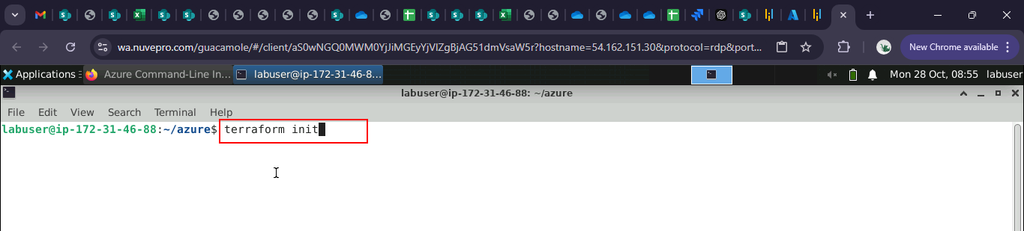

The terraform is successfully initialized.

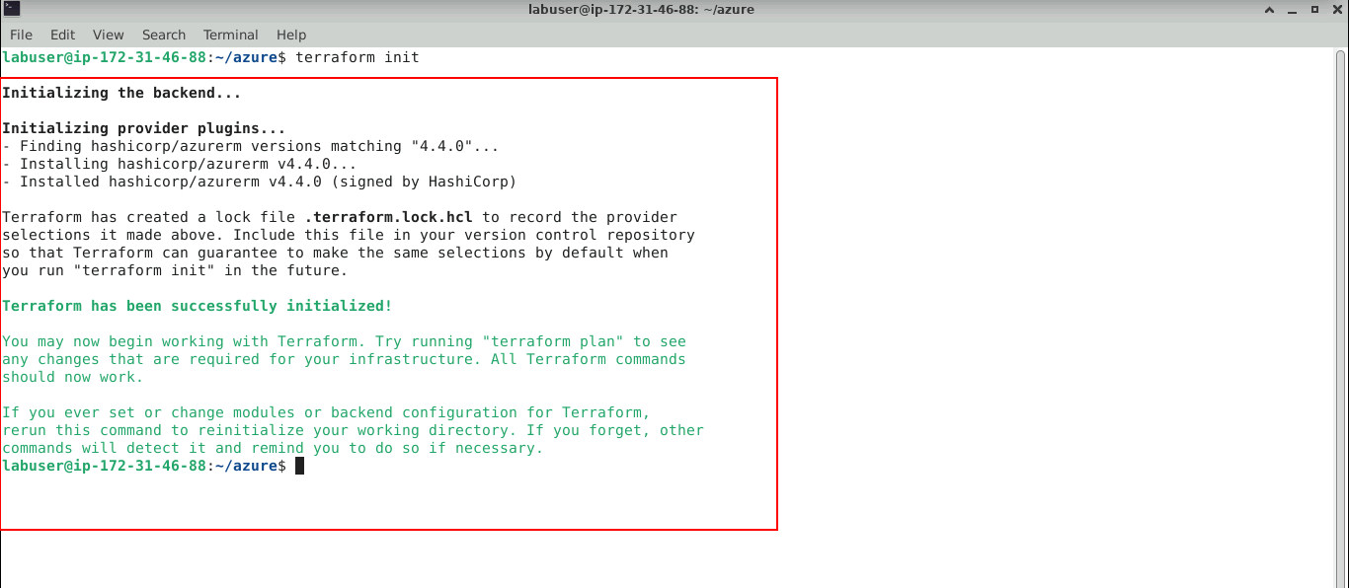

  - Execute the command below to apply the Terraform initialization
terraform apply

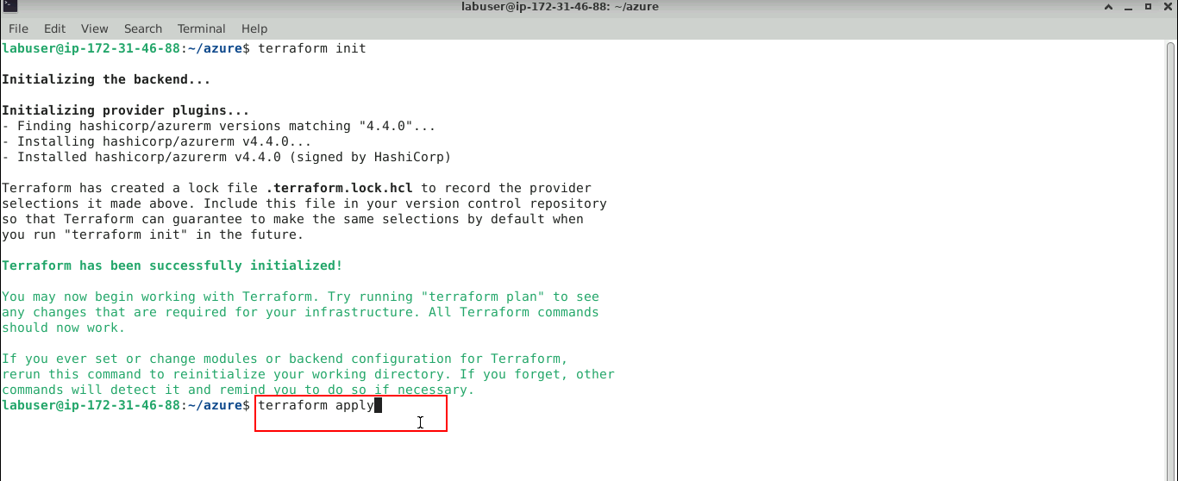

  - Enter yes to run the apply

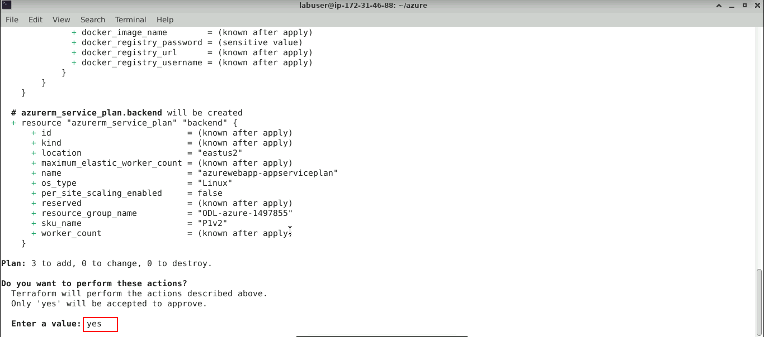

The Terraform apply ran successfully.

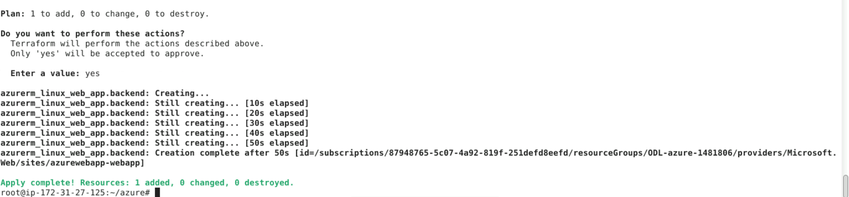

  - Navigate back to the Azure portal logged in during step 1.18 to validate the newly created application

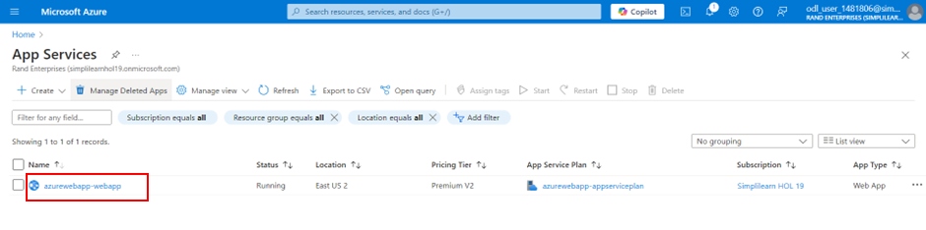
Note: If an

Step 3: Configure Jenkins to automate CI CD workflow

- Open the browser in the lab and enter the URL below
http://localhost:8080/

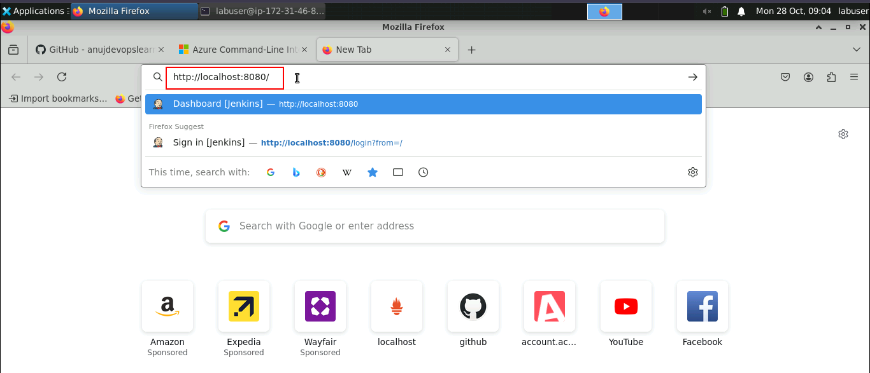

- Enter the Username and Password, and click the Sign in button

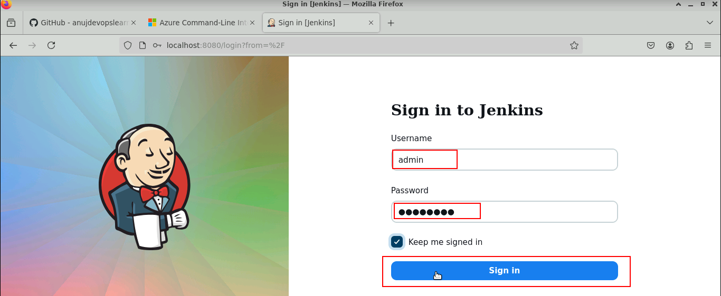

Use the below credentials for the login:
Username: admin
Password: Root123$

The Jenkins dashboard opens up as shown below.

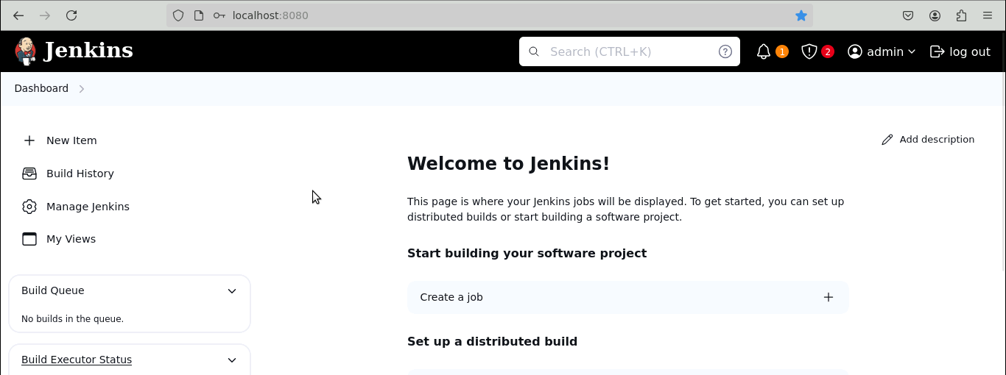

- Naviagte back to the terminal and run the below command to validate if docker runtime is installed:
docker version

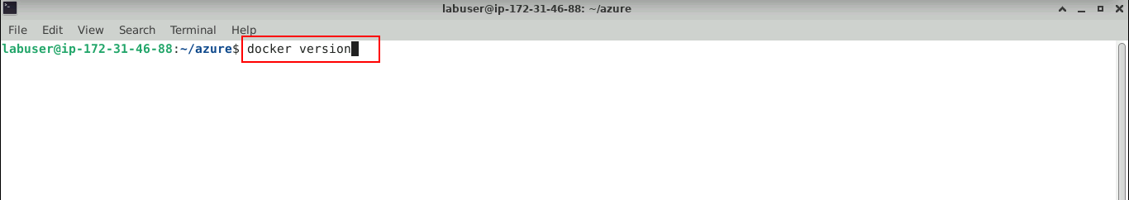

The docker is installed properly, as shown below.

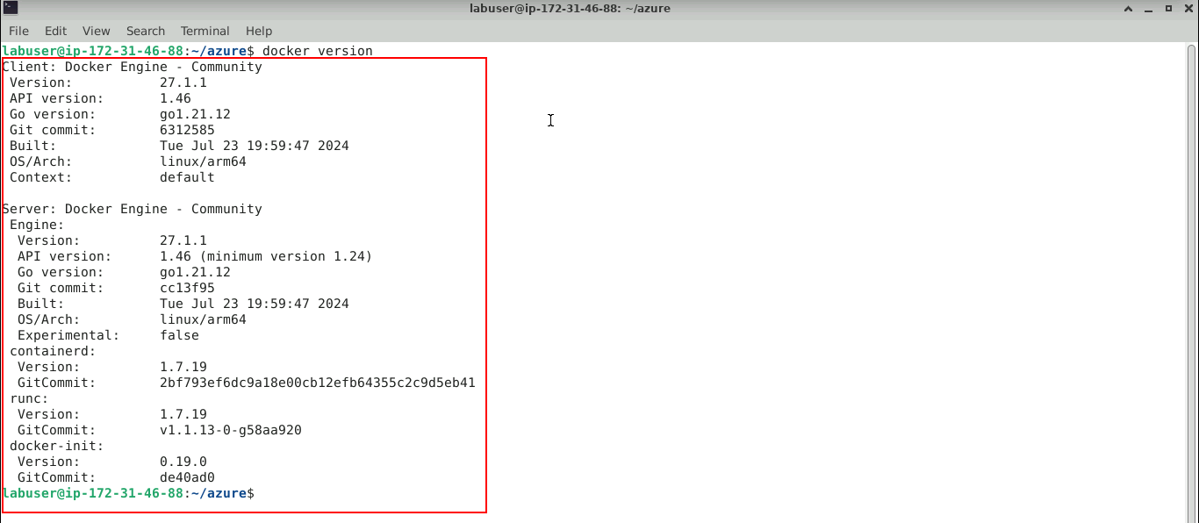

- Fork the GitHub repository below and validate that Maven scripts are present in the code repository to execute the Jenkins pipeline:
https://github.com/GithubWorkstation/SpringBootApplication

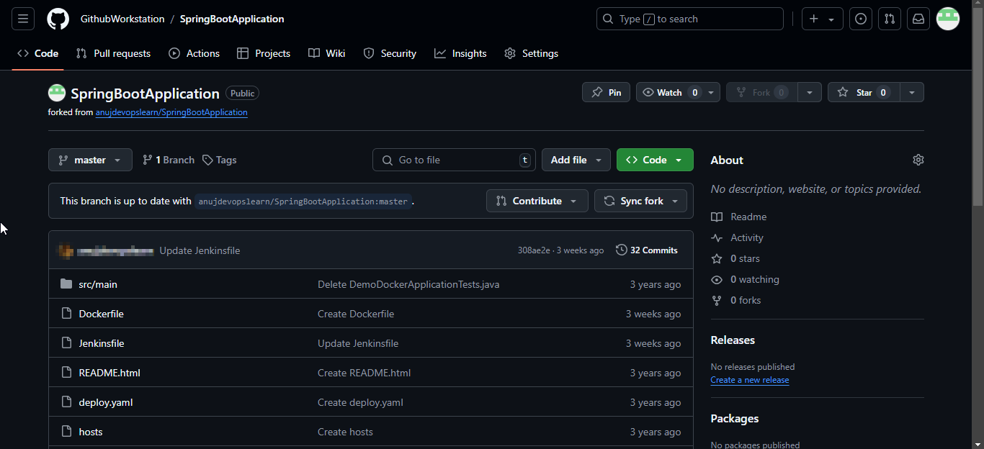

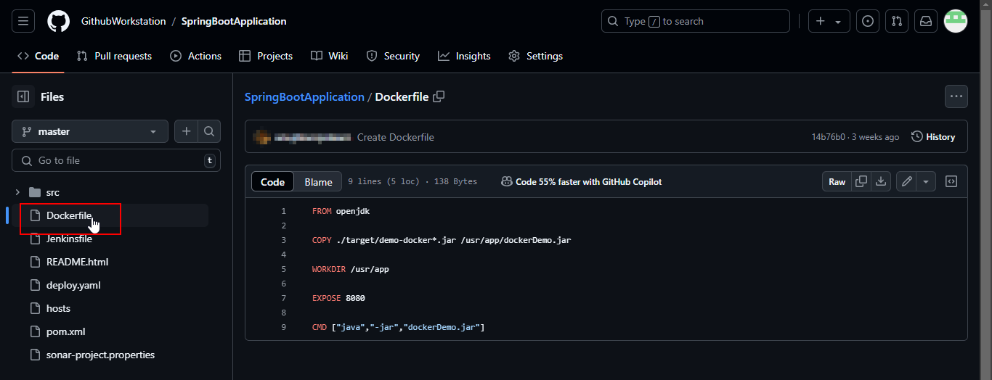

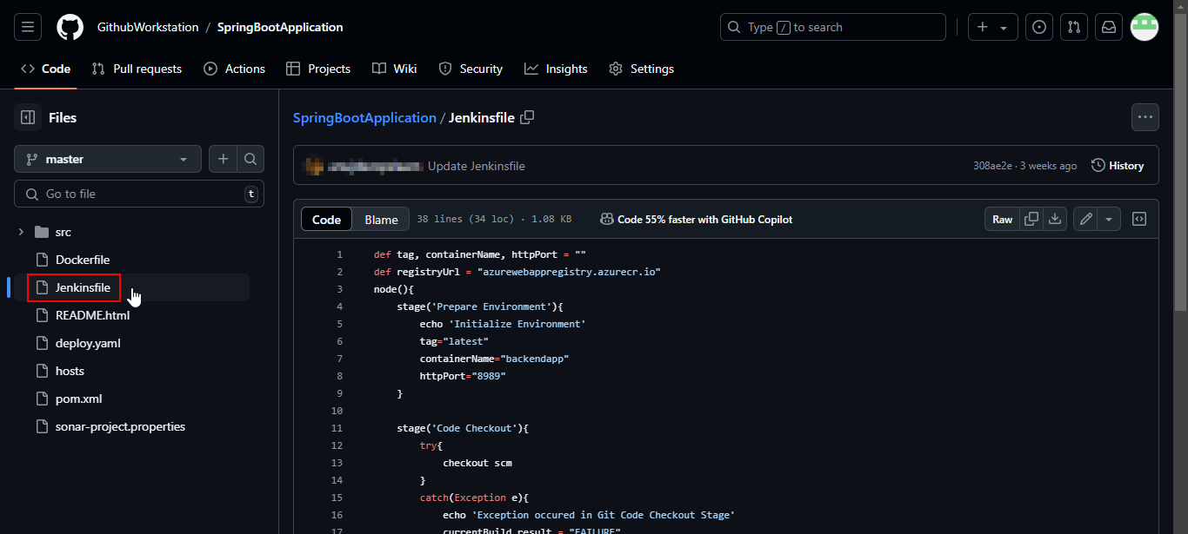

- Navigate to the Jenkins dashboard and click on + New Item

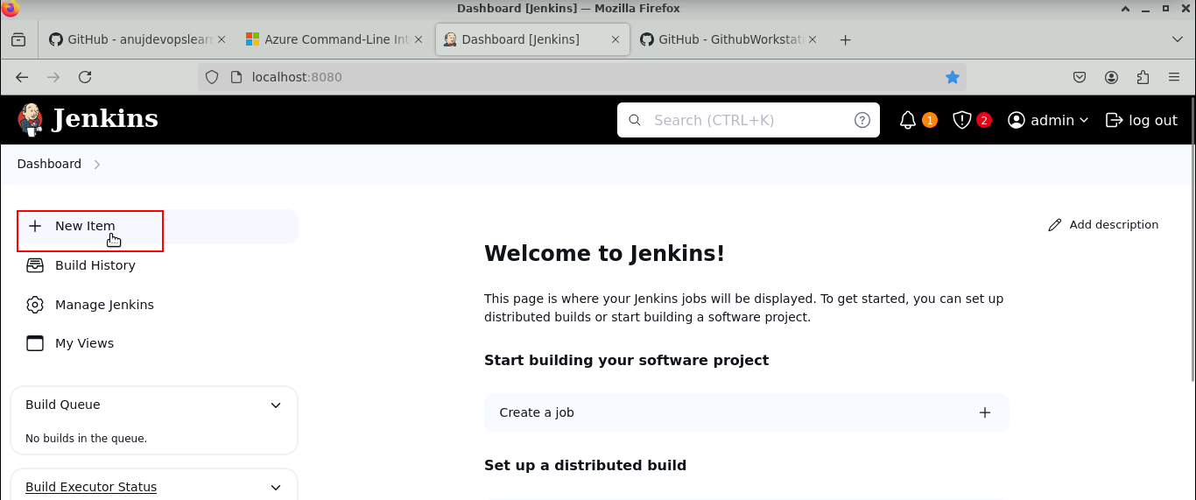

- Enter the job name as CICDPipeline, select the job type as Pipeline, and click OK

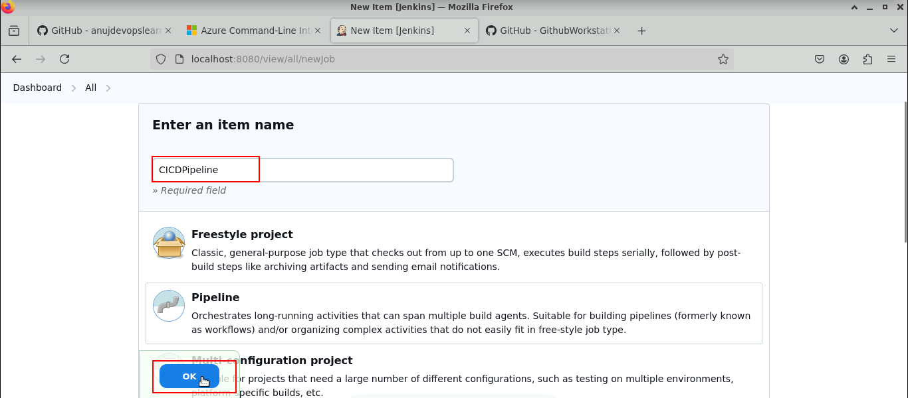

- Provide Jenkins job details, such as parameters and pipeline configuration, on the Jenkins job configuration page

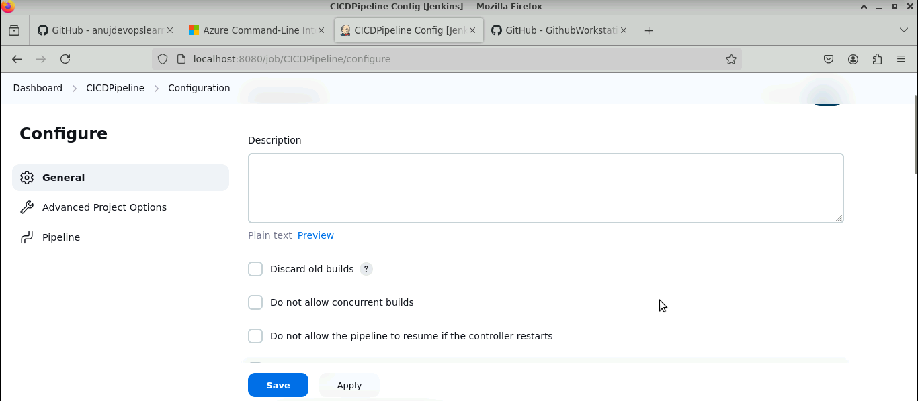

- Enter the Definition, Pipeline script, and Script Path

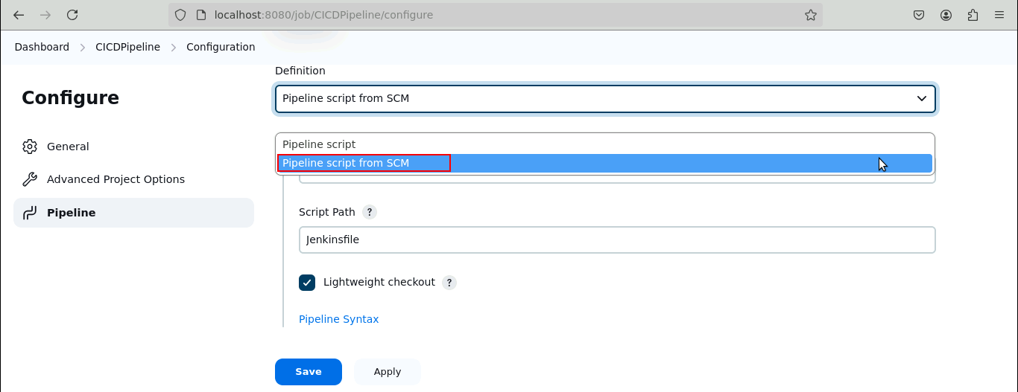

- Under SCM choose Git

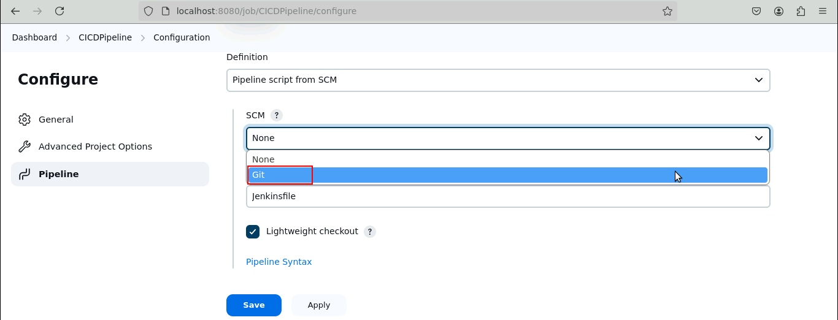

- Enter the Repository URL as given below and select the Credentials as Jenkins:
https://github.com/GithubWorkstation/SpringBootApplication

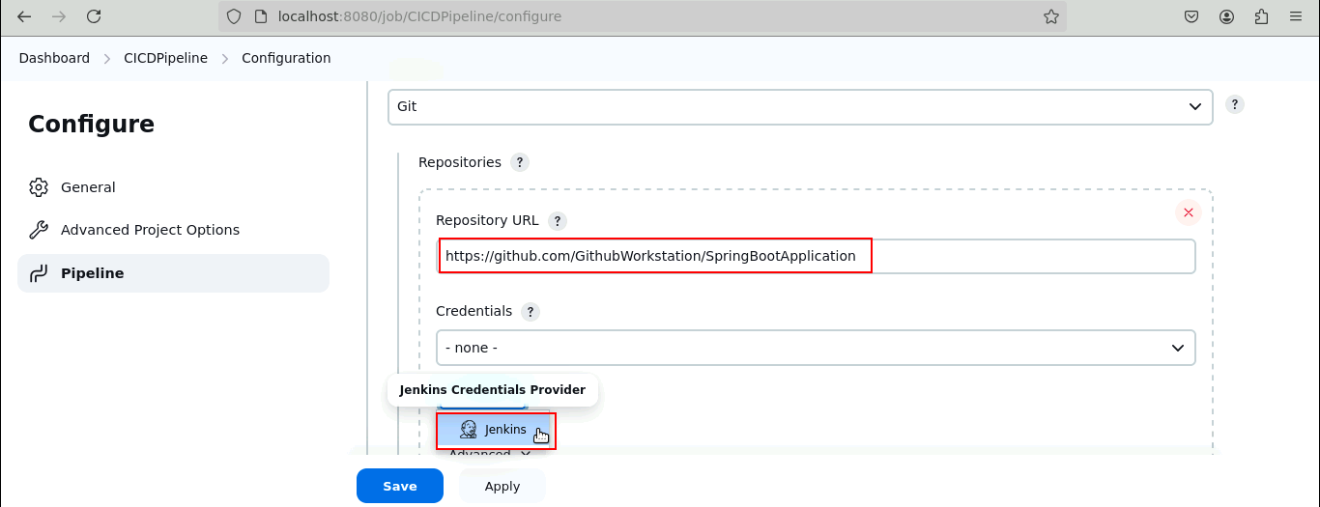

- Enter the Script Path as Jenkinsfile and click the Save button

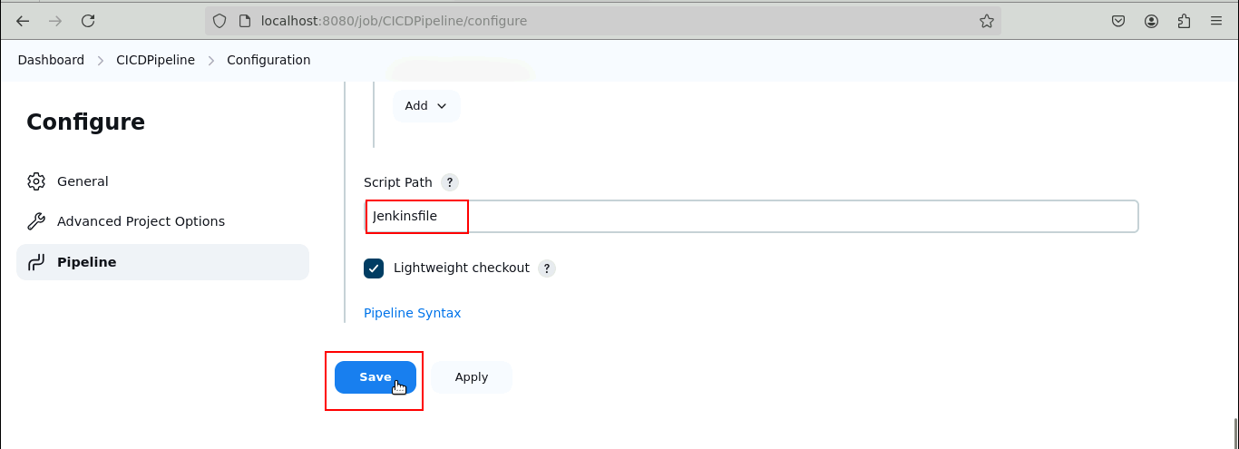

- Verify that the code checkout stage is included in the pipeline script

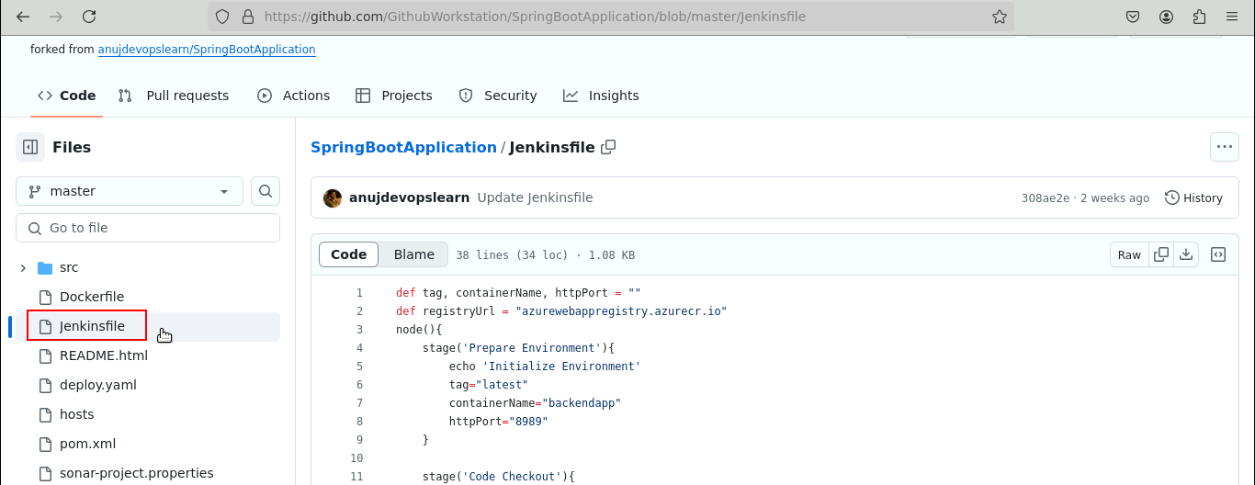

- Navigate to Azure Container Registry and select the desired registry

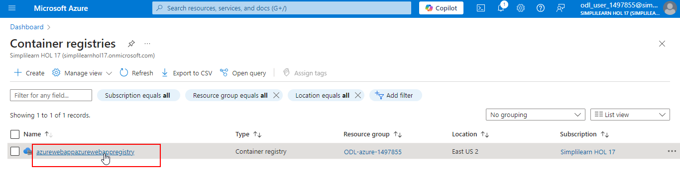

- Click on Access keys to retrieve the username and password, which will be used to configure Jenkins credentials

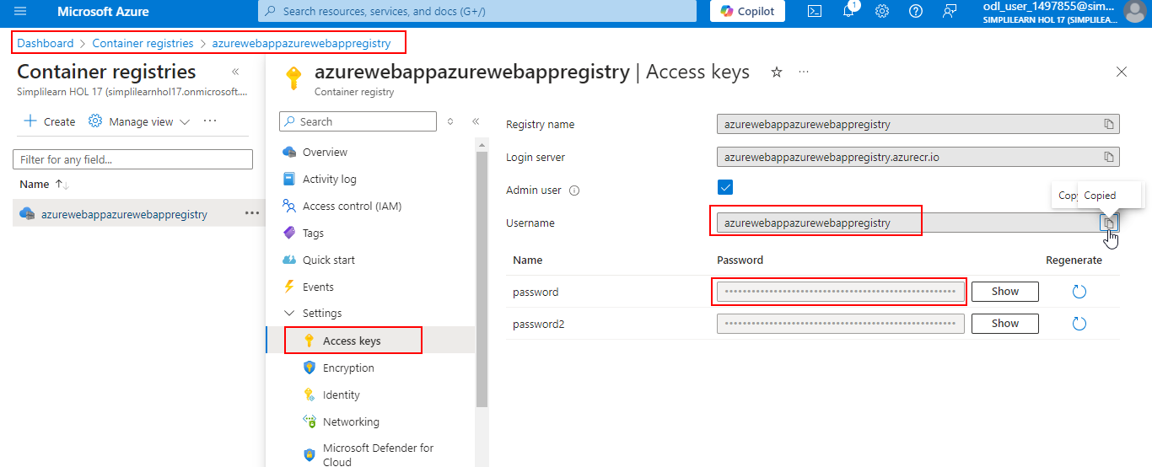
- Navigate to the Jenkins dashboard and click on Manage Jenkins

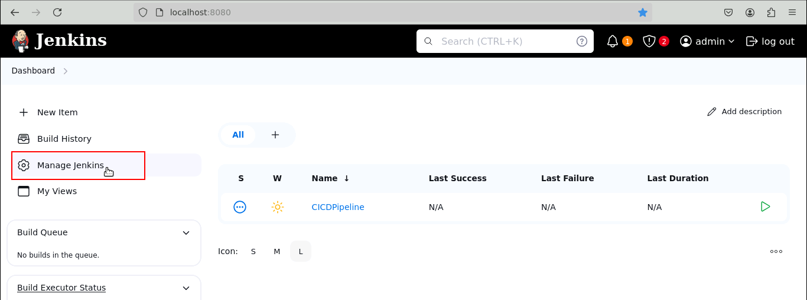

- Click on Credentials

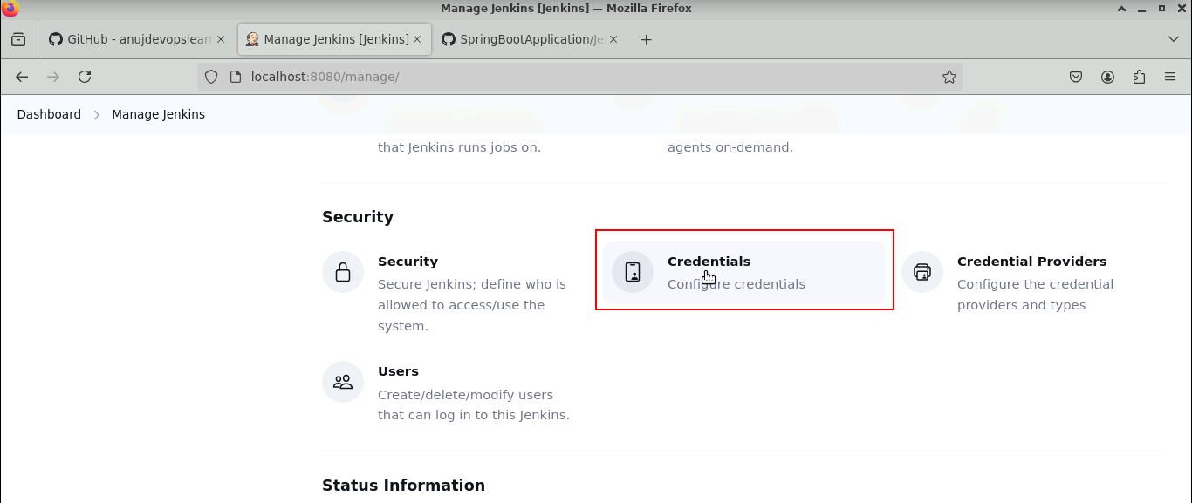

- Select the Global domain

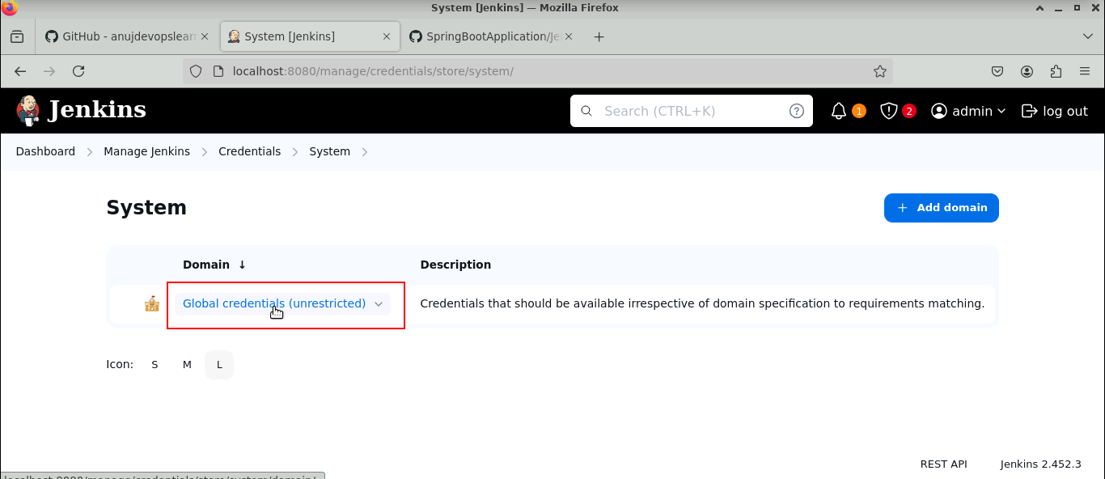

- Click on Add Credentials

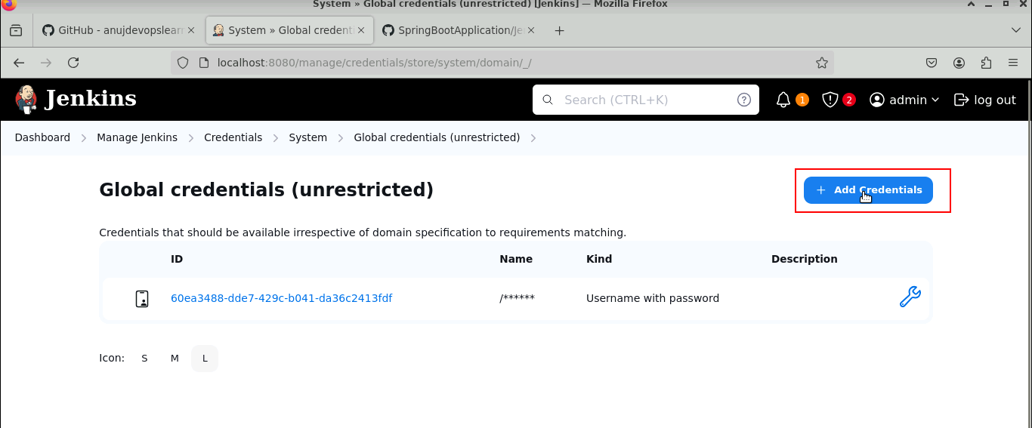

- Enter the Username retrieved in step 3.14

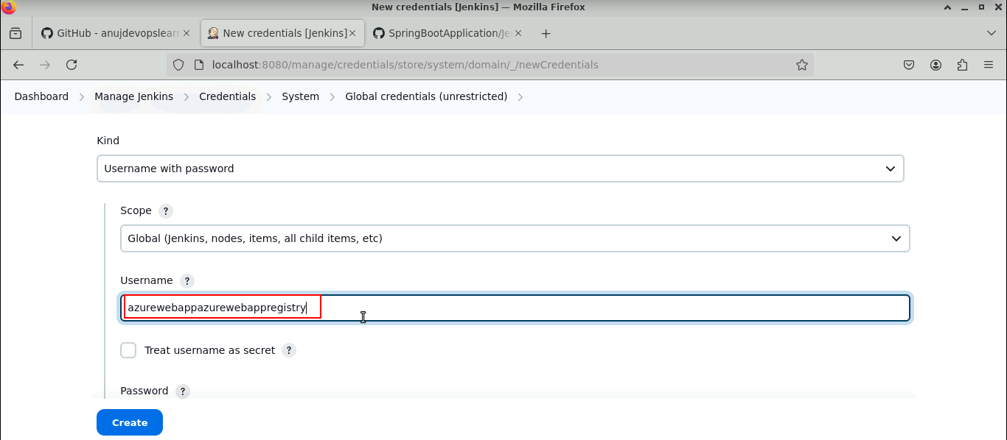

- Enter the ID as dockerACRaccount and the Description as ACR Credentials, then click the Create button

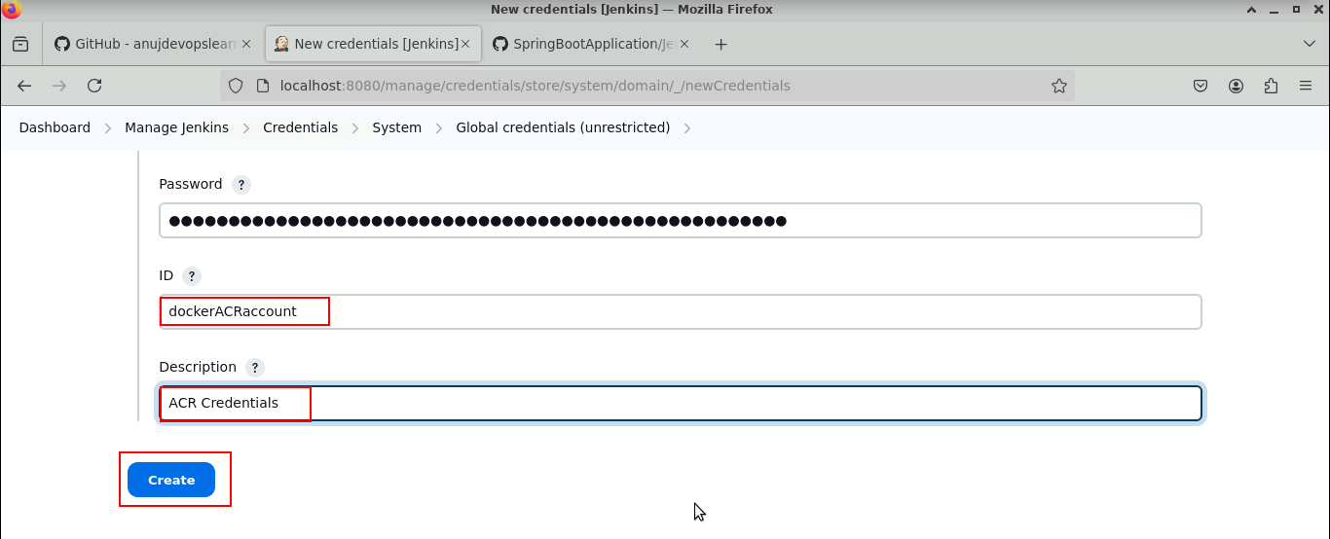

The credentials are updated successfully.

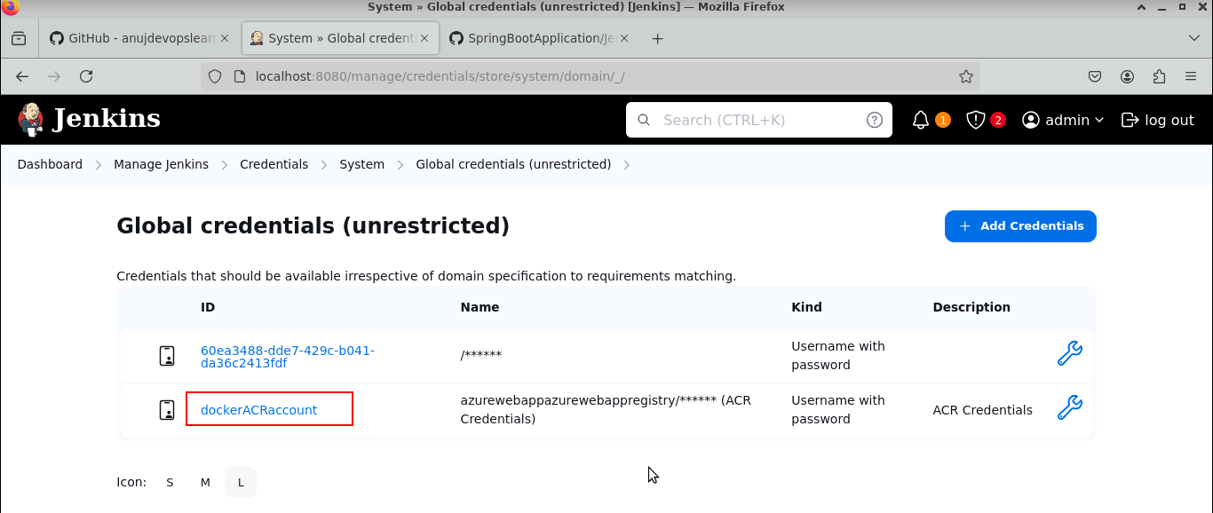

- Navigate back to the terminal and run the command below to grant full access to the Docker sock file
sudo chmod 777 /var/run/docker.sock

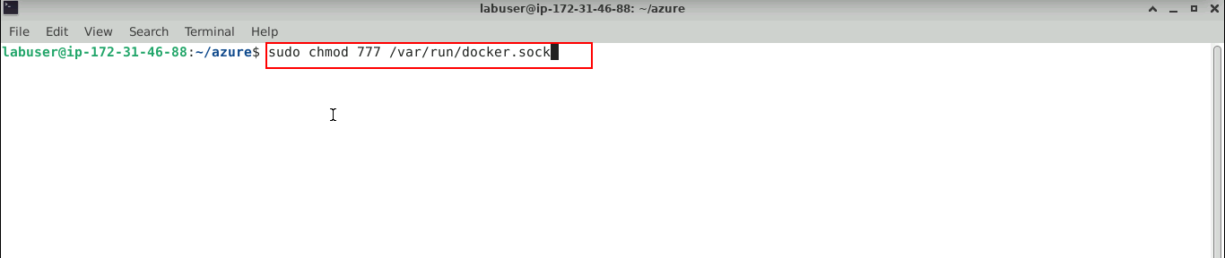

The access command ran successfully, as shown below.

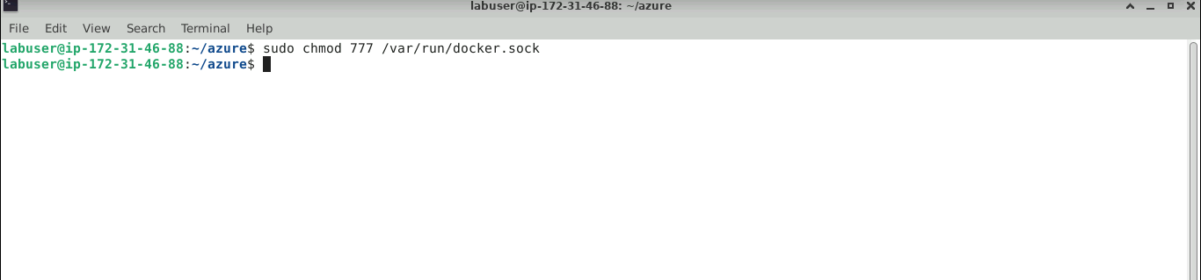

- Navigate to Jenkins and click on Build Now

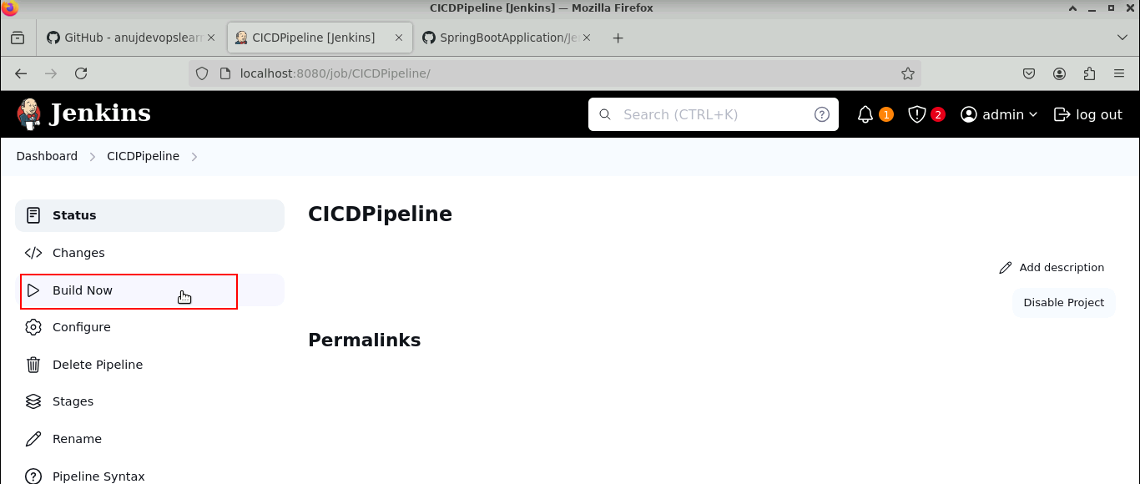

The pipeline starts building, as shown below.

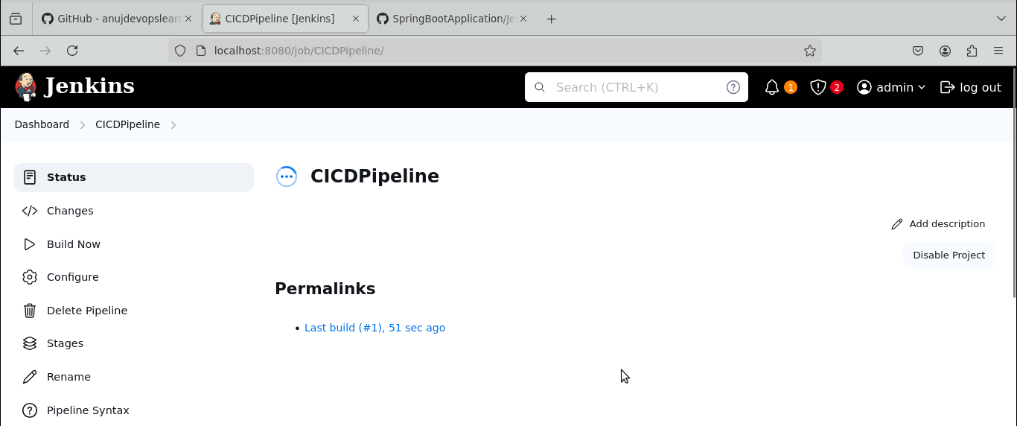

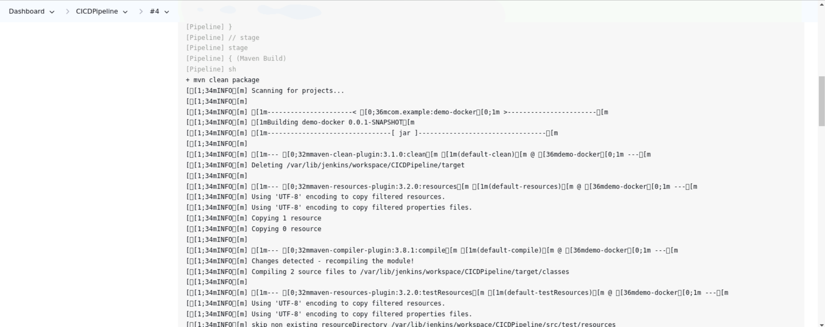

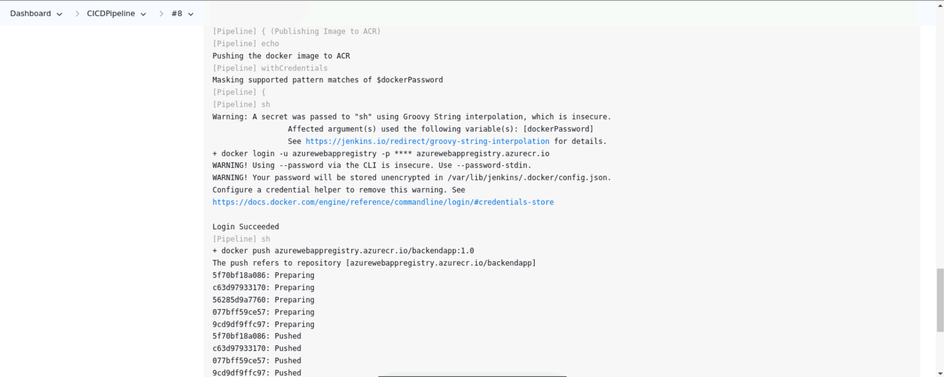

- Navigate to ACR and select the registry published by the Jenkins pipeline

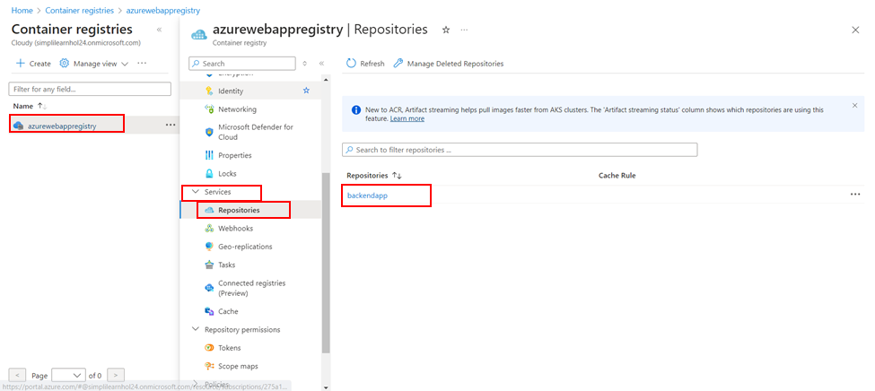
- Configure the Azure Web App with the latest Docker image tag, as shown in the screenshot below:

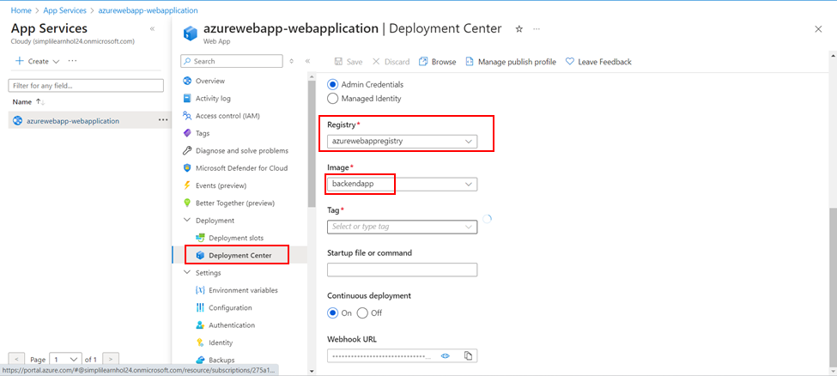

- Once the configurations are selected, click Save, which will force the Azure Web App to restart, automatically picking up the latest Docker image and deploying it on the Azure Web App

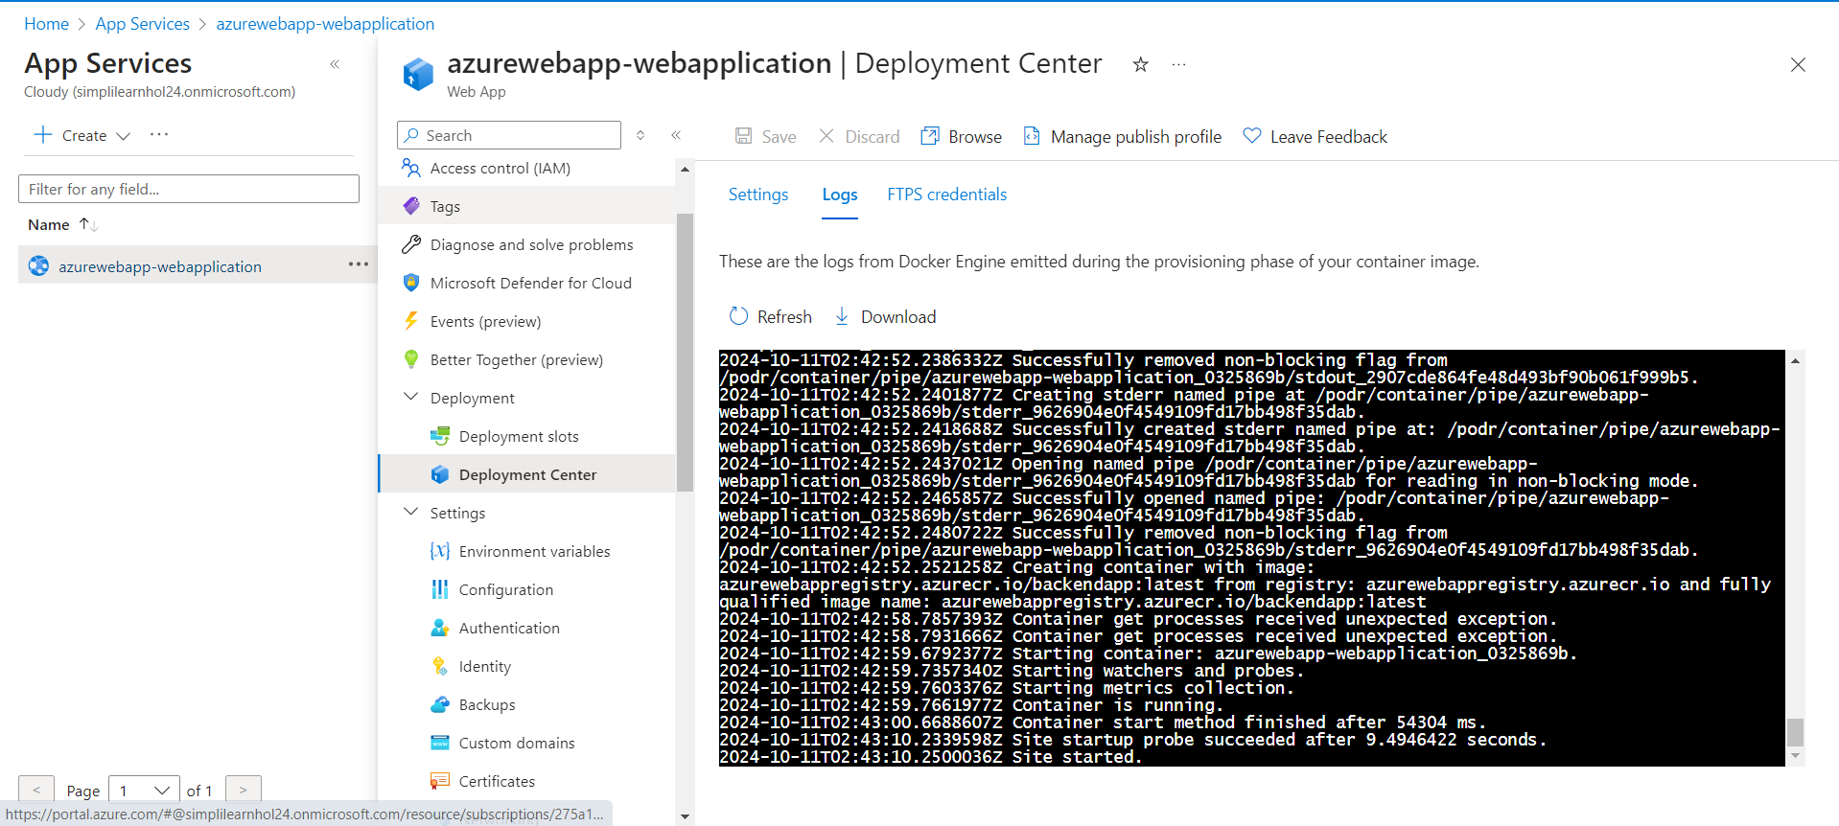

- Copy the Application URL to access the Backend Application

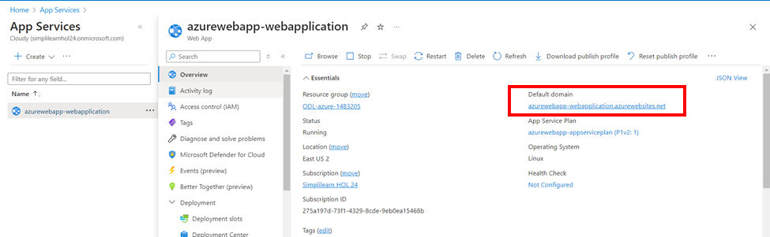

- Open the URL in the browser

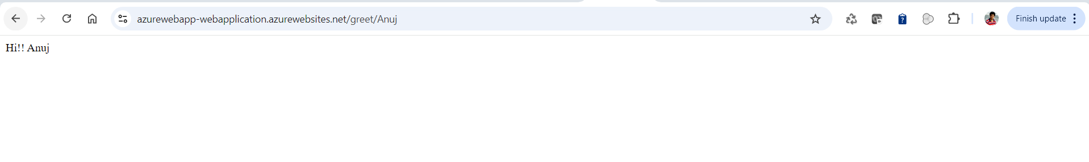

By following these steps, you have successfully automated the provisioned infrastructure, enabling the creation of a new Azure Web App and the automation of CI/CD workflows to deploy microservices applications.

